~Asia-China-Mirror-Warring States (475-221 BCE)-Arc 8-Bat 4

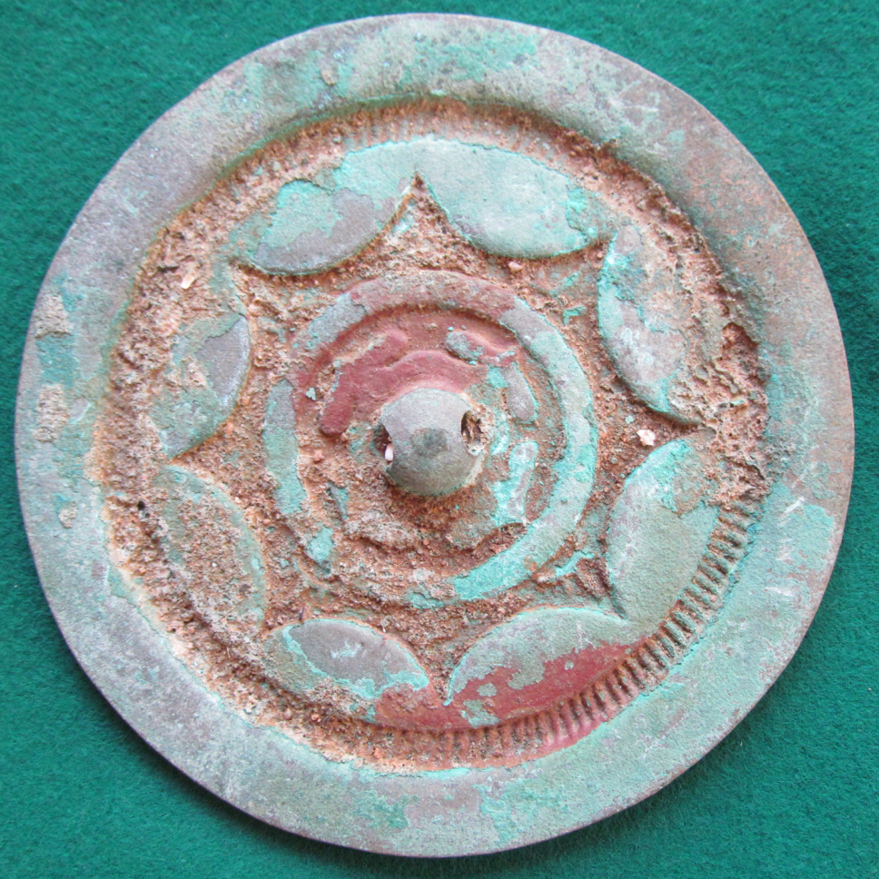

his relatively plain eight continuous arc, 4 bat bronze mirror reflects Warring States simplicity.